Sample websites and social media Content. Feel free to adapt.

SAMPLE WEBSITE/INTRANET POST

Do you know how to #KeepFamiliesSafe from family violence?

Today, 1 in 3 Canadians is very concerned about family stress due to isolation and 1 in 10 women is very concerned about family violence. The research is clear: family violence escalates during a pandemic. And, just as individual, collective actions were critical to flatten the Covid-19 curve, simple, collective action is needed to help flatten the family violence curve.

You can help. A coalition of local agencies and municipalities has launched the #KeepFamiliesSafe campaign to: raise awareness of rising family violence, to help people know the signs and to share simple ways anyone can help at home, at work and in the community.

Visit www.preventingcrime.ca/KeepFamiliesSafe to find out more.

Twitter (character count) and FB Posts

GENERAL

DYK? - 1 in 3 Canadians is very concerned about family stress - 1 in 10 women is very concerned about family violence Will you #KeepFamiliesSafe by helping to reduce and prevent family violence? Small gestures save lives. Visit www.preventingcrime.ca/keepfamiliessafe
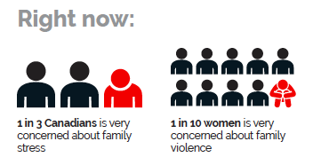

Family violence affects us all. Here are 3 things you can do to defuse a tense situation and help #KeepFamiliesSafe. Visit www.preventingcrime.ca/keepfamiliessafe for more.
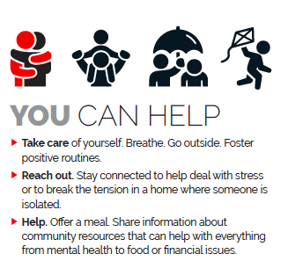

It’s a fact: family violence escalates during a pandemic. Do you know the signs? Here are 3 things you can do to help #KeepFamiliesSafe. Visit www.preventingcrime.ca/keepfamiliessafe for more. @WomensCrisisSWR @facswaterloo @wrpstoday
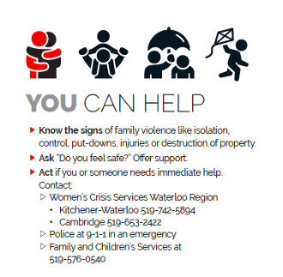

It’s a fact: family violence escalates during a pandemic. Isolated seniors are particularly at risk of fraud, emotional or physical abuse. Reach out to people who are isolated. Offer to help. Know the signs. Visit www.preventingcrime.ca/keepfamiliessafe Help #KeepFamiliesSafe
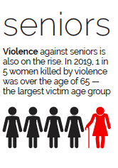

CHILDREN AND YOUTH (next two weeks)

This summer, some kids may not have as many community supports as usual and family stress is high due to COVID. Let’s help #KeepFamiliesSafe by taking care of ourselves and looking out for one another. Visit www.preventingcrime.ca/keepfamiliessafe
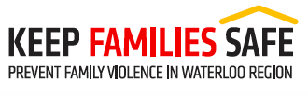
OR

In Waterloo Region alone,
…… almost 3 times every day a young person finds the courage to tell someone that they are experiencing abuse. Do you how to help reduce or prevent family violence? Visit www.preventingcrime.ca/keepfamiliessafe #KeepFamiliesSafe or contact @facswaterloo

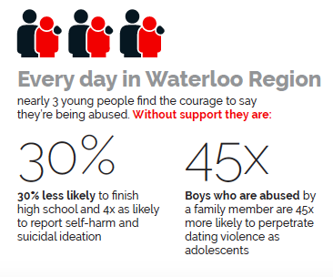

LinkedIn Post

Name of individual/organization or group is so pleased to work with a coalition of 14 agencies and municipalities to launch the #KeepFamiliesSafe campaign to prevent and reduce family violence in Waterloo Region.
At work, home and in the community do you know the signs? Would you know what to do?
While global research shows that the shadow pandemic of family violence is the second, silent wave of COVID, it also shows that simple gestures can be effective to defuse the tension.
Visit https://lnkd.in/eCxJhD6 to find out more #KeepFamiliesSafe

Link to Infographic

